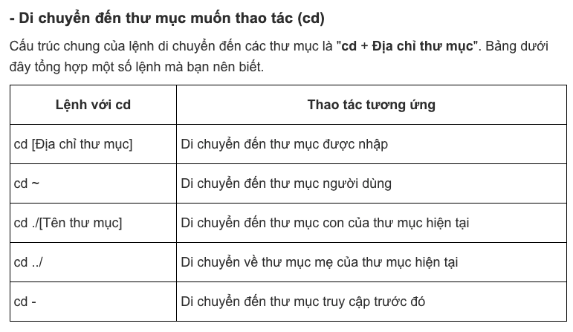

Nếu muốn tạo các thư mục lồng nhau thì thêm -p vào phía trước

Tạo file sau đó mở file ra xem

